EXERCISE 13 REACTJS-HOL

Explain Various Ways of Conditional Rendering
React provides multiple ways to perform conditional rendering. The most common include if or if-else statements for complex conditions, the ternary operator (condition ? trueBlock : falseBlock) for inline expressions, and the logical AND operator (condition && element) when you only want to render something if a condition is true. Additionally, you can use element variables to store components based on conditions and include them in JSX. Each approach is chosen based on readability and complexity of the logic being handled.

Explain How to Render Multiple Components
Rendering multiple components in React can be done by simply returning them within a container like a div, or using fragments (<>...</>) to avoid adding extra nodes to the DOM. You can also render multiple components inside arrays when mapping over data. For example:
return (
<>
<Header />
<Main />
<Footer />
</>
);
This renders all three components together without adding an unnecessary parent element.

Define List Component
A list component in React is a component that renders a collection of data items, typically using the JavaScript map() function. Each item is usually represented by a child component. For example, a StudentList component might render multiple Student components using a list of student data. Lists make the UI dynamic and scalable as data changes.

Explain About Keys in React Applications
Keys are special attributes used in React when rendering lists of elements. They help React identify which items have changed, been added, or removed, which is essential for efficient updating and rendering. A key should be a unique and stable identifier, often the item’s ID. For example:
{students.map(student => <Student key={student.id} name={student.name} />)}
Using keys improves performance and prevents unexpected UI behavior.

Explain How to Extract Components with Keys
When rendering a list, it's best practice to extract each item into its own component and pass a key to it. This helps keep the code modular and reusable. For example:
function StudentList(props) {
return (
<ul>
{props.students.map(student =>
<Student key={student.id} name={student.name} />
)}
</ul>
);
}
Here, the Student component is extracted, and each instance is given a key to help React track updates efficiently.

Explain React Map, map() Function
In React, the map() function is commonly used to iterate over an array of data and return a new array of JSX elements. This is especially useful for rendering lists. For example:
const students = ['Ava', 'Ben', 'Chris'];
const listItems = students.map((name, index) => <li key={index}>{name}</li>);
This converts the array of names into a list of <li> elements. Using map() ensures your UI is automatically updated when the data changes.

HANDS-ON EXERCISE:
STRUCTURE:
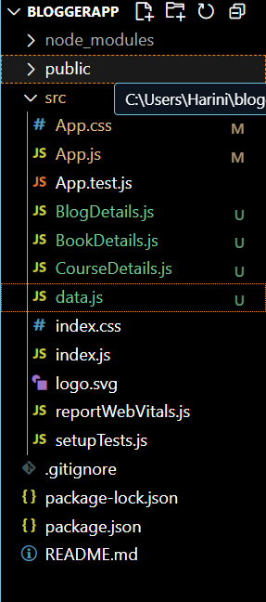

CODE:
App.js
import React, { useState } from 'react';
import './App.css';
import BookDetails from './BookDetails';
import BlogDetails from './BlogDetails';
import CourseDetails from './CourseDetails';
import { books, blogs, courses } from './data';

function App() {
const [showSection, setShowSection] = useState('books'); // default

return (
<div className="App">
<h1> Blogger App</h1>
<div className="nav">
<button onClick={() => setShowSection('books')}>Books</button>
<button onClick={() => setShowSection('blogs')}>Blogs</button>
<button onClick={() => setShowSection('courses')}>Courses</button>
</div>

{showSection === 'books' && <BookDetails books={books} />}
{showSection === 'blogs' && <BlogDetails blogs={blogs} />}
{showSection === 'courses' && <CourseDetails courses={courses} />}
</div>
);
}

export default App;
App.css
.App {
text-align: center;
font-family: Arial, sans-serif;
padding: 20px;
background: #f4f4f4;
min-height: 100vh;
}

.nav {
margin-bottom: 20px;
}

.nav button {
padding: 10px 20px;
margin: 5px;
background-color: #0d6efd;
color: white;
border: none;
border-radius: 5px;
cursor: pointer;
}

.nav button:hover {
background-color: #0a58ca;
}

.section {
background-color: white;
padding: 20px;
margin: 10px auto;
border-radius: 10px;
width: 80%;
box-shadow: 0 4px 8px rgba(0,0,0,0.1);
}

.card {
margin: 10px;
padding: 15px;
border-bottom: 1px solid #ddd;
}

BlogDetails.js
import React from 'react';

function BlogDetails({ blogs }) {
return (
<div className="section">
<h2>Blog Details</h2>
{blogs.map((blog) => (
<div key={blog.id} className="card">
<h3>{blog.title}</h3>
<p>Author: {blog.author}</p>
</div>
))}
</div>
);
}

export default BlogDetails;
BookDetails.js
import React from 'react';

function BookDetails({ books }) {
return (
<div className="section">
<h2>Book Details</h2>
{books.map((book) => (
<div key={book.id} className="card">
<h3>{book.bname}</h3>
<p>Price: ₹{book.price}</p>
</div>
))}
</div>
);
}

export default BookDetails;

CourseDetails.js
import React from 'react';

function CourseDetails({ courses }) {
return (
<div className="section">
<h2>Course Details</h2>
{courses.map((course) => (
<div key={course.id} className="card">
<h3>{course.cname}</h3>
<p>Duration: {course.duration}</p>
</div>
))}
</div>
);
}

export default CourseDetails;

data.js
export const books = [
{ id: 101, bname: 'Master React', price: 670 },
{ id: 102, bname: 'Deep Dive into Angular 11', price: 800 },
{ id: 103, bname: 'Mongo Essentials', price: 450 }
];
export const blogs = [
{ id: 201, title: 'React Hooks', author: 'Dan Abramov' },
{ id: 202, title: 'Understanding JSX', author: 'Ryan Florence' }
];
export const courses = [
{ id: 301, cname: 'Full Stack Development', duration: '3 months' },
{ id: 302, cname: 'Frontend with React', duration: '2 months' }

]OUTPUT:

